**PARTICIPANT SUMMARY**

After pre-screening multiple candidates, we shortlisted a pool of 10 participants making it a very diverse and forthcoming people from varied demographics. This good mix increases the chances of getting different perspectives fulfilling the purpose of the research.

Six of our participants consist of young adults aged 18-30. This group of people are often considered as tech savvy and usually do not require too frequent medical care. The rest of the pool consists of people aged 41+. This group of people may or may not be highly proficient in using technology and some of them suffer from chronic diseases requiring them to regularly visit the doctor. Our survey was dominated by women constituting 70% and the rest 30% identified as men.

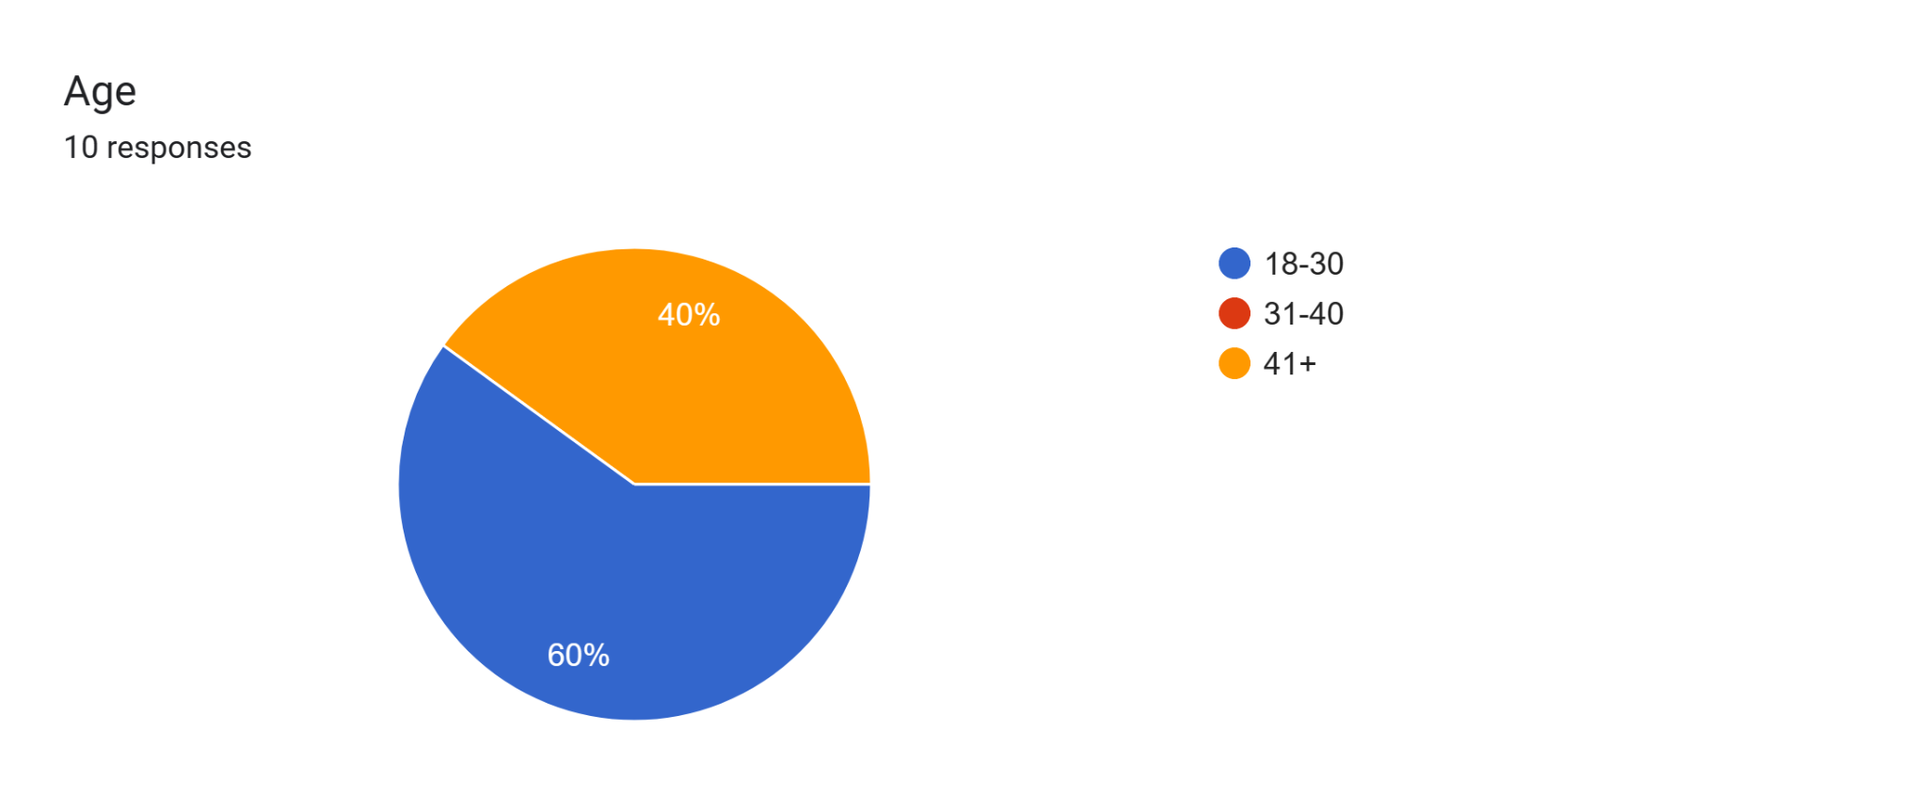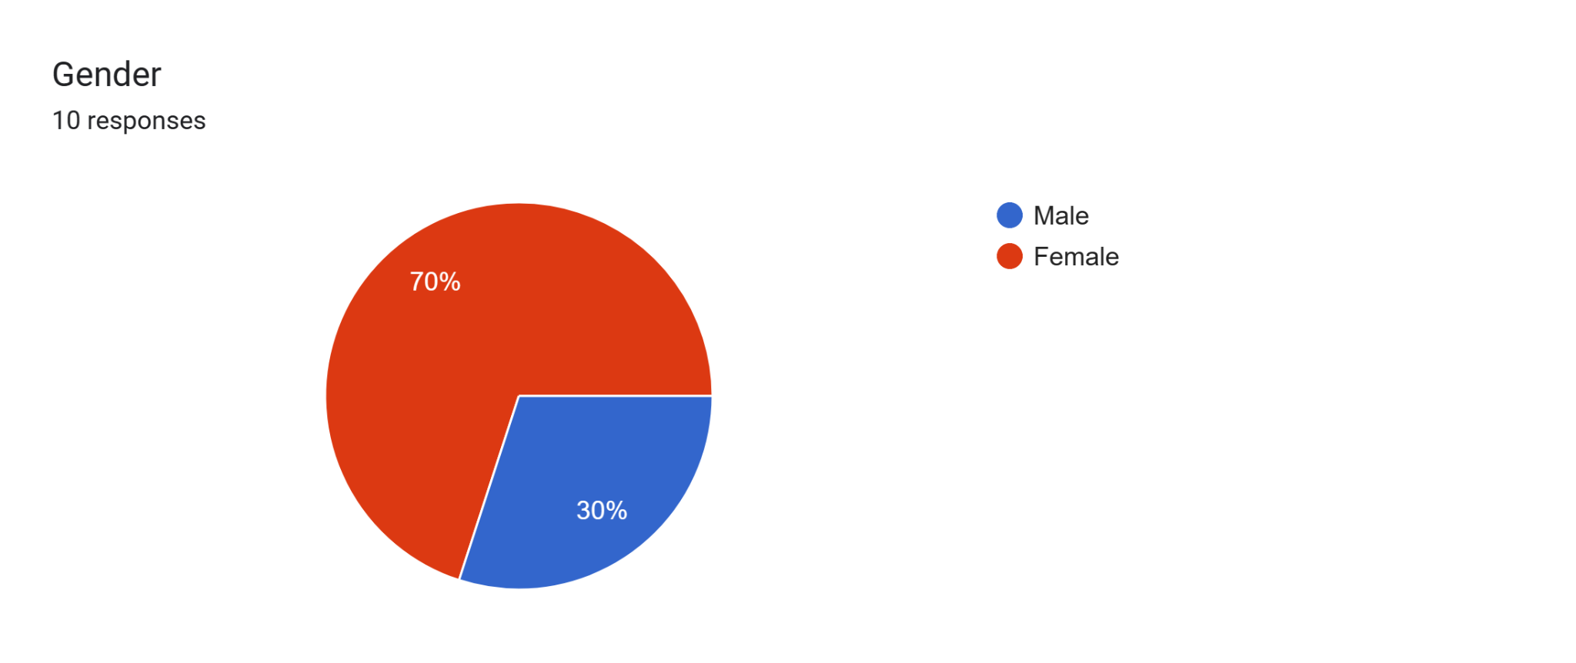

Different regional markets are dominated by different web apps and platforms used to book doctor’s appointments. So it was essential for us to pick people from countries having systems that varied from others to get universal feedback. For example people in India either preferred web apps like Practo or hospital websites to secure a visit. While north american countries preferred apps like Maple or contact the doctor’s office directly for a specialized appointment.

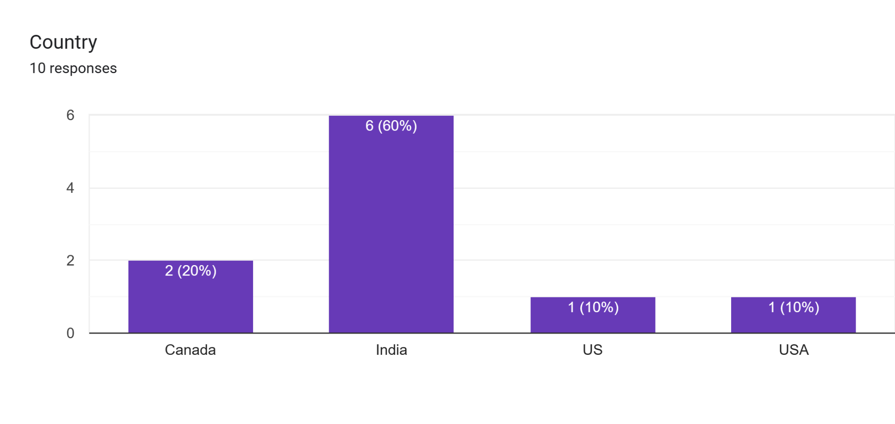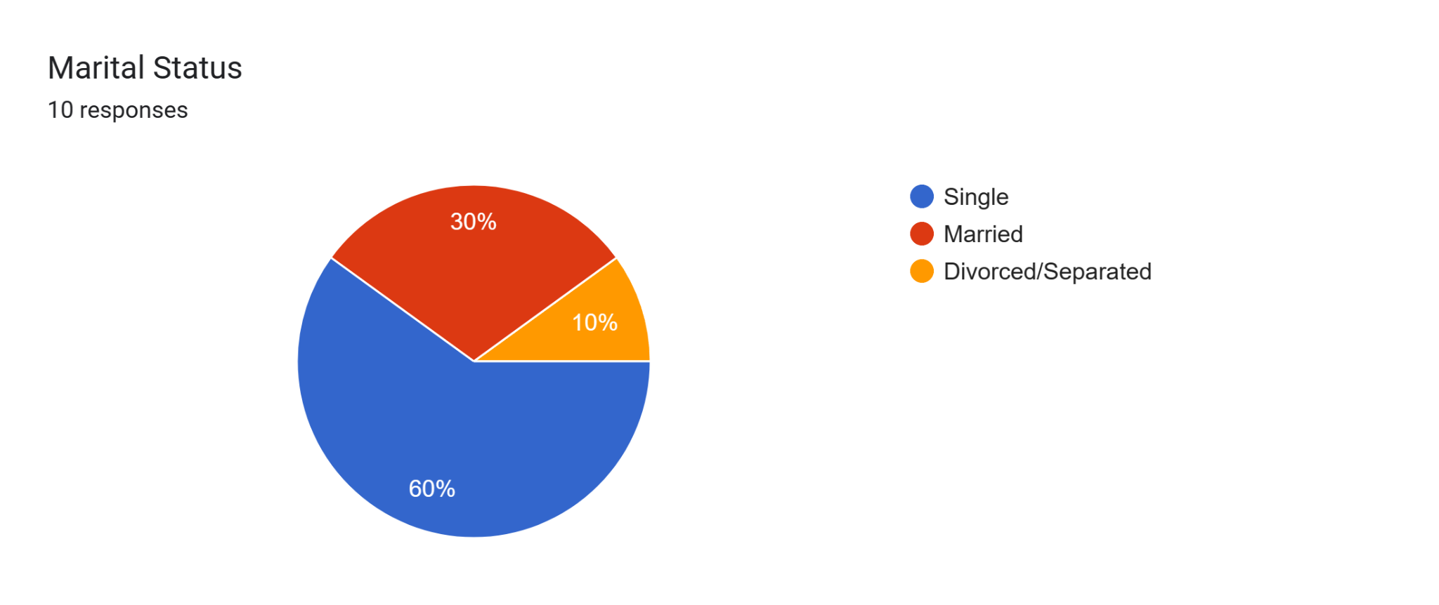

Our pool of participants had people from different walks of life. Half of them were employed, one of them retired and 4 identified as students or home makers. This speaks to us about how busy people’s lives are and the importance of an easy to use hassle free booking software. Technical proficiencies also varied making us focus on understanding the need for a right balance between appealing and simplicity in UX designs.

